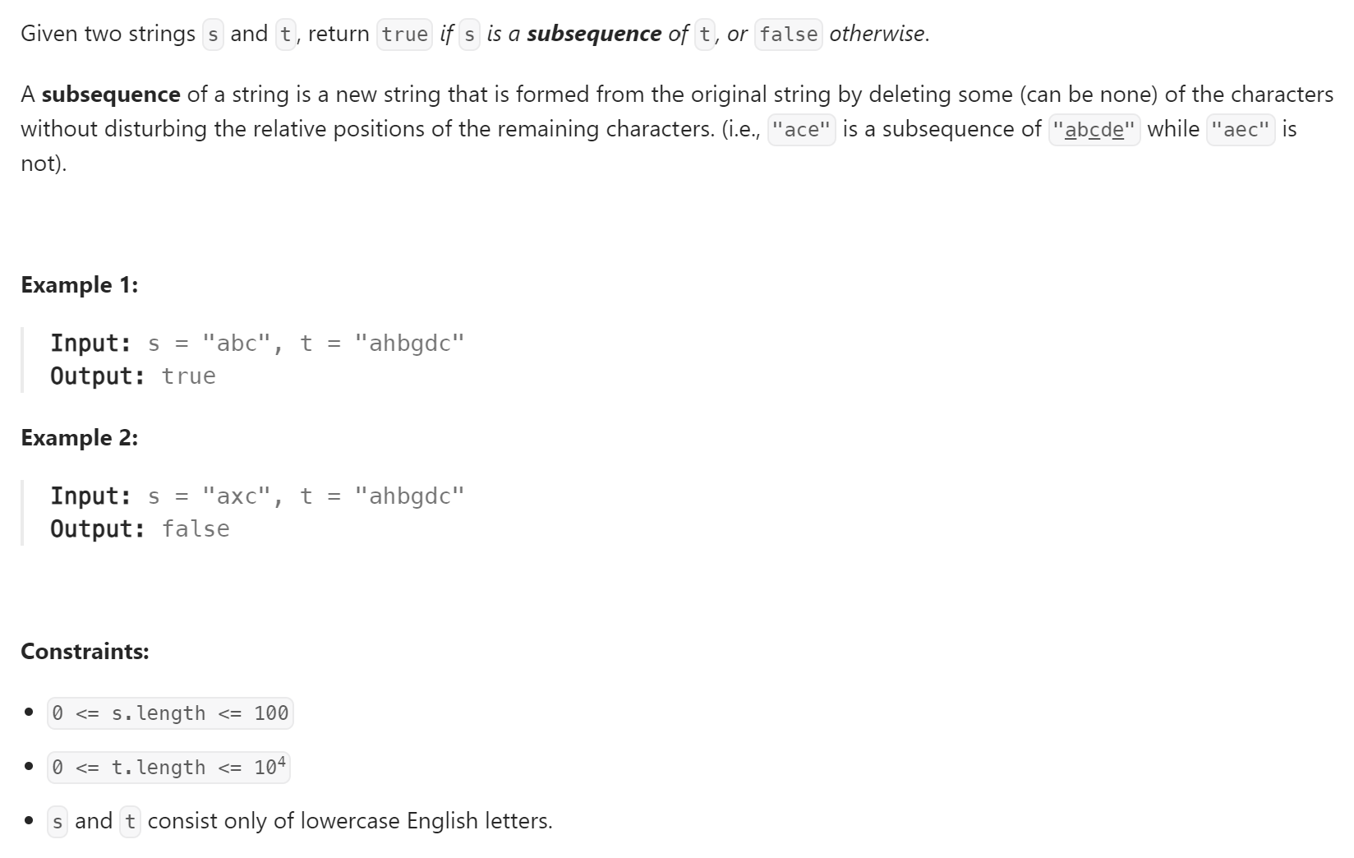

**Follow up:** Suppose there are lots of incoming s, say s1, s2, ..., sk where k >= 109, and you want to check one by one to see if t has its subsequence. In this scenario, how would you change your code?